Cabinet Committee on Performance Improvement
Meeting to be held on 5th December 2018

Electoral Division affected:
All

Customer Access Performance Report

Contact for further information:
Sarah Jenkins, (01772) 537401, Head of Service - Customer Access
sarah.jenkins@lancashire.gov.uk

Executive Summary

This report provides an update for the Cabinet Committee on Performance Improvement on the operation and performance of the Customer Access Service.

Recommendation

The Cabinet Committee on Performance Improvement is asked to comment on and note the contents of this report.

Background and Advice

The Customer Access Service currently deliver first point of contact for telephone, email and social media interactions for 28 Lancashire County Council services, handling over 1.1 million customer interactions a year. This equates to roughly two thirds of all customer contacts coming into the Council.

In addition to this, the Customer Access Service also process 24,800 Blue Badge applications, over 5,000 Crisis Support Applications, and over 51,700 Customer Satisfaction feedback reports.

These services are diverse and vary widely from booking a wedding, handling sensitive safeguarding reports, to reporting a pothole. Each service has its own data handling tool(s) which we record contacts in, requiring Customer Access staff to be able to competently use over 25 separate specialist systems.

The Customer Access Service provides specialist teams to ensure the best use of resource to deliver the range and volume of services in a cost effective manner. Advisors are multi-skilled and trained to handle enquiries on a variety of services across a variety of channels, using a best of breed telephony platform to route these interactions to the correct person for resolution.

Customer Access operates between 8am and 6pm, Monday to Friday and employs staff to cover 190.5 full-time equivalent posts.

Given the current financial climate, Customer Access are already working towards multiple savings targets with various existing programmes of work.

The following table illustrates the volume of contacts presented for all services delivered through the Customer Access Service, April to September 2018, along with comparisons with the corresponding period from the previous year.

Customer Access Service overall performance – April to September 2018

Measure | 2017/18 | 2018/19
Telephone Calls Received | 469,026 | 458,108
Telephone Calls Answered | 417,001 | 414,628
% Answered | 88.9% | 90.5%
emails Received | 93,433 | 95,454
emails Completed | 93,099 | 96,195
% Completed | 99.6% | 100.0%
Social Media Received | n/a | 867
Social Media Completed | n/a | 867
% Completed | n/a | 100.0%
Total Contacts Received | 562,459 | 554,429

The reduction in contacts received is an indication that we may be starting to realise achievements in the ongoing campaign to assist appropriate channel shift for services, allowing effective self-service through the website. The decrease in telephony contacts and corresponding increase in email contacts also reflects the continuing effect of ongoing vacancies within the service which reduces the resource available to answer calls. The attrition rate within Customer Access has increased over the past 18 months largely due to an increase in opportunities elsewhere within the authority.

We continually measure performance so that:

- We can demonstrate that enquiries are handled without undue delay. This is as a result of the accurate forecasting of call volumes by 15 minute interval by day. We then compare the forecast to the actual performance.

- Customer experience is assessed by analysing data from our customer satisfaction surveys and as a result processes are re-engineered to deliver the optimum experience.

- Regular communication and feedback from senior managers is taken on board. We meet periodically with Heads of Service to discuss the specific service needs.

Performance, Transformation & Improvement Programme
The service is actively involved with delivering requirements to support the following work areas within the above programme:

Adults Social Care
The percentage of Adult Social Care calls and emails received into Customer Access that result in a referral to Adult Social Care has remained consistent at 9.5% with a further 22.5% resulting in the requirement for some other form of assessment or review from the Social Work teams.

There has been ongoing liaison between the two services during the Service Challenge process to look at a more effective and robust front door in order to help manage the increasing demand on the Adults Service. Customer Access will take part in an Association of Directors of Adult Social Services Peer Review in November 2018 to help identify both best practice and potential opportunities for improved working practises.

In addition to this, a current project to analyse the Adult Social Care call traffic within Customer Access has already identified a number of potential improvement opportunities that will both enhance the customer experience and realise efficiencies within Customer Access.

Adult Safeguarding
The accuracy and timeliness of Customer Access was recently singled out for praise by external consultants who were commissioned to review the Multi Agency Safeguarding Hub service. The performance management within Customer Access was highlighted as being 'rarely found in the public sector' and, following on from the review, Customer Access will be heavily involved in the redesign of the front door for Adults Multi Agency Safeguarding Hub, building on current best practice to improve efficiency and manage risk

Children's Social Care
There has been a slight reduction in contacts handled by the Customer Access Service for Children's Social Care as a result of fewer repeat and follow up calls. The move towards callers discussing cases and concerns directly with Social Workers is now fully embedded and, following the project to analyse the Adult Social Care call traffic within Customer Access, we hope to realise further efficiencies and improvements to the customer experience.

Early Help Module
In October 2018, the Liquid Logic Early Help Module system module was brought in to enable more collaborative working and to simplifying the step up and step down process between Children's Multi Agency Safeguarding Hub and the Children, Families and Wellbeing Service. In January 2019, Special Educational Needs and Disabilities will also begin to use this module.

As the existing front door for many Multi Agency Safeguarding Hub referrals, the Customer Access Service has been a key element within the project; amending our processes and retraining staff to use the new Early Help Module whilst continuing to use the Liquid Logic system for cases already open to Children's Social Care.

Children Not in Education, Employment or Training
Customer Access are currently working with the Learning & Skills Service in order to provide a clearer picture on data for young persons aged 16-19, who are not in education, employment or training. This will involve liaising with young people as well as parents and guardians, employers, and education and training providers, and will also consider different contact and communication methods in order to maximise engagement. This is an ongoing piece of work and will focus on a cohort of around 2,500 young people (10% of all school leavers) currently listed as either not in education, employment or training or with an unknown status. This will allow the Learning & Skills Service to focus on particular areas of need to reduce not in education, employment or training numbers going forward. The proposal is that this element of work will transfer to the Customer Access Service in the new financial year.

AskHR Service
As part of the Customer Access savings programme, funding for 7 full time equivalent posts was reduced in April 2018 for the AskHR Service and temporary funding from within the Customer Access Service budget was agreed until December 2018. The project has focused on the online uptake of Human Resources enquiries and customer self-service to reduce the volume of HR contacts.

Analysis reports were produced looking at both telephony and email enquiry types to support the development and introduction of a new Managers' Toolkit. The Toolkit provides the information, guides and support that managers need on a regular basis.
As part of the analysis reports, Customer Access have also reviewed the AskHR telephony messages to simplify the options presented to customers, raise awareness of the Managers' Toolkit and provide improved reporting; specifically in relation to popular HR enquiry types.

Blue Badge Service
Improvements in application processing time, waiting times, and the uptake of the Blue Badge online application system continues to be sustained in the Customer Access Service. The approval rate of Blue Badge applications so far this year is 85% and as at end of October 2018, there were a total of 58,283 Blue Badges in circulation.

Lancashire County Council delivers the Blue Badge Service on behalf of the
Department for Transport and Customer Access have recognised that some applicants find their online application process difficult. We therefore offer an assisted application service where we will make an appointment at a convenient time for the customer and contact them in order to complete the application using the information they provide. 1,401 assisted applications have been completed so far this financial year. We have also updated the Blue Badge section on the Lancashire County Council website to include information for applicants.

The Blue Badge Service continues to offer a fast track application process for terminally ill Blue Badge applicants (also known as palliative care applications).

Crisis Support
The number of Crisis Support applications received for the year so far is 2,001, the approval rate has decreased to 35% compared to 39% in 2017/18. This has been due to improved signposting allowing us to find alternative solutions for our citizens. The number of applications received this year has also reduced, partially influenced by the change from monetary awards to the provision of food parcels. It should also be noted that numbers received last year were influenced by the problems experienced with tax credits, the same issues have not occurred this year.

The tables below illustrate the assistance provided by the Crisis Support scheme for the first two Quarters of 2018/2019.

Applications for assistance with food & fuel – April to September 2018

Period | Received | Awarded | Declined
- April - June | 727 | 178 | 549
- July - September | 701 | 190 | 511
TOTAL | 1,428 | 368 | 1,060

Applications for assistance with furniture – April to September 2018

Quarter | Received | Awarded | Declined
- April - June | 294 | 168 | 126
- July - September | 279 | 165 | 114
TOTAL | 573 | 333 | 240

Education Management System

In September 2017 a new Online School Admissions system was introduced allowing customers to apply for Primary and Secondary school places. The new online system provides a complete self-service approach from applying and submitting an application, though to the publication of online results for school places.

During the summer of 2018, further work has been done to review previous performance and improve the system. Work has included revision of the communication messages and amending the way school names appear in the system for an improved customer experience.

Family Information Service
As part of a Customer Access Service improvement review advisors no longer use the Synergy system as it was identified that this did not add value to the process. Benefits realised from this change include greater efficiency and an improved customer experience along with a simplified, shortened training programme.

The Customer Access Service has also worked closely with Corporate Communications to further develop and promote the digital channel for the service, allowing customers to self-serve. In addition, the scope for first point of contact resolution has been increased slightly which has helped Customer Access reduce the impact on the service workload.

Highways Systems
The new Highway Asset Management system went live on 1 April 2017, and work continues to embed usage within the Highways service. Customer Access are supporting this work, contributing to regular Governance Board meetings and liaising closely with the service to develop and improve use of the customer module by both The Customer Access Service and the Highways service. The customer experience is a key consideration for this work, and the intention is to improve the amount of information available for the customer at the first point of contact by working with the service to improve communication.

There have also been multiple updates to the online self-service Report It portal. The intention is for customers to be able to use this to both report and see progress updates. Customer Access have considered the customer experience and provided input for design and testing.

NoWcard Renewals
Extra support from the Customer Access Service was given to the main cohort of NoWcard renewals that expired at the end of March 2018 and the project proved to be successful. This was extended through April and May to ensure that support was available for all the 180,000 NoWcards expiring.

School Transport
As part of a transformation programme initiated by the Customer Access Service, a new 5 year (Gold Pass) was introduced in July 2018. Advisors now handle enquiries in relation to both this and the online Season Ticket which was introduced in May 2017. Recently, we have worked with the service and the Communications team to promote the season ticket in the run up to the new September school year.

Customer Access Service Specific projects

Restructure of the Service
In July 2018 the Customer Access Service undertook a restructure of the service which was successfully implemented in September 2018. The service redesign reduced the operating hours in line with agreed savings and provided a clearer, more balanced framework in order to successfully deliver the service and achieve the additional economies required moving forward.

The number of senior managers has reduced and roles have been redefined in order to ensure that each member of staff is accountable for tasks that are appropriate to their grade. This will allow staff to focus on specific elements of the business, ensuring ownership and accountability as well as encouraging them to develop and improve processes. It is intended that this will provide a consistency of work that will both improve quality and generate greater levels of efficiency.

Crucially, the new structure offers different development pathways for all staff, providing opportunities that will expose them to different tasks and allow them to build the skills and experience required to develop their career within the service. The retention of staff will be a key element in the success of the service moving forward and the ability to demonstrate tangible career pathways, as well as actively nurturing talent within the service, will be crucial in achieving this.

Internal Audit
An internal audit was completed in October 2018 to determine the adequacy and effectiveness of the administration of the Crisis Support Scheme. Substantial assurance was provided that the framework of control is both adequately designed and effectively operated, ensuring the efficient provision of awards to eligible individuals.

Areas of good practise highlighted within the report included the detailed process guides in place, the thorough eligibility checks undertaken and the effectiveness of regular performance monitoring in ensuring that applications are completed in line with the Crisis Support Scheme policy.

Recruitment
An internal review of recruitment has been conducted in order to improve the retention of staff within Customer Access. Assessment days have been introduced in order to test and observe potential employees, strengthening the recruitment process and showcasing the benefits of Lancashire County Council as an employer. These will continue to be developed and refined, incorporating the anticipated changes that the new Oracle Recruitment System will bring in order to select the right candidates in the most timely and thorough manner.

The table below illustrates the number of Customer Service Advisors recruited so far during 2018/2019.

Customer Service Advisors recruited – April to September 2018

Period | Customer Contact Centre | Social Care | HR
April – September | 6 | 14 | 0

Training

The table below illustrates the number of Training Sessions that have taken place so far during 2018/2019, along with the number of Advisors who have been trained.

Advisors trained – April to September 2018

Service Area | Customer Contact Centre |  | Social Care |  | HR
Period | Sessions | Agents | Sessions | Agents | Sessions | Agents
April - September | 51 | 326 | 25 | 148 | 11 | 46

An additional 25 bespoke training sessions have also been delivered to 148 members of staff on a variety of systems and skills, developing staff within their roles.

Savings
The current financial year to date has seen a further reduction in both budget and headcount within Customer Access, continuing the trend over the last three years. Future savings have been agreed but are dependent on technology implementation. The savings in the Customer Access Service delivered to date have totalled £1,005,000, and we have seen a reduction of 44.4 full time equivalent posts (the saving quoted includes a transfer of £58k 2.50 full time equivalent posts to the Emergency Duty Team). It should be noted that the budget for the Customer Access Service is based almost entirely on staffing and therefore in order for Customer Access to make the necessary saving reductions, staffing levels must be reduced. Reducing headcount without reducing the work coming through the centre will result in longer wait times for callers and callers having to abandon calls and make several further call attempts before resolving their enquiry. This could lead to complaints and have a negative impact on the reputation of the authority.

The projects delivered to date are:
- The removal of the Lancashire House reception support function, and
- The reduction in Social Care opening hours.

Work continues across the other projects to deliver:
- A Social Care Portal,
- Improved HR self-service,
- Telephony automation,
- Making reductions against the Customer Access Service support function, and
- The full blending of email contact into the service with telephony.

Service Plan and Vision
The Customer Access Service Plan and Vision have been reviewed and approved by Stephen Young (Executive Director of Growth, Environment and Communities), Sue Procter (Director of Programmes and Project Management) and Councillor Peter Buckley. It supports a customer focused approach to service delivery, and encourages a channel shift to digital customer solutions. It also demonstrates the Customer Access Service contribution and commitment to:

- Increasing and improving 'access channel change',
- Reducing the cost of service delivery by promoting self-service and automation for specific services, and
- Ensuring that the services provided keep the citizens of Lancashire at the core of what we do.

Whilst there is a focus on digital contacts, customers will not be excluded because they do not have internet access at home. Lancashire residents will still have telephone access to our trained advisors who understand the specific services areas.

Genesys Programme Phase 2 - Technology Improvements
As part of the development of the Genesys toolkit, the Customer Access Service has overseen the implementation of AskHR and Children's Social Care emails onto the Genesys platform in order to blend them with telephony contacts presented to advisors. This is more efficient and avoids the manual handling of reports and data between systems.

Handling emails in Genesys has allowed more visibility of workloads, quicker handling times and more accurate forecasting and reporting. A project to move Adult Social Care emails onto Genesys is now being developed following which all email contact throughout Customer Access will be successfully blended with traditional telephony contacts.

New Hardware equipment
The Customer Access Service managed the delivery of a full PC asset refresh across all departments to provide new Lenovo assets with increased memory and performance speeds. The asset refresh was followed by an upgrade to wider, flat screen monitors, allowing advisors to open more windows within the screen and therefore enabling them to carry out tasks more efficiently. Headsets were also upgraded to include better audio controls, noise reduction features and acoustic shock cancelling hardware.

Telephony & Email Performance

Telephony performance – April to September 2018

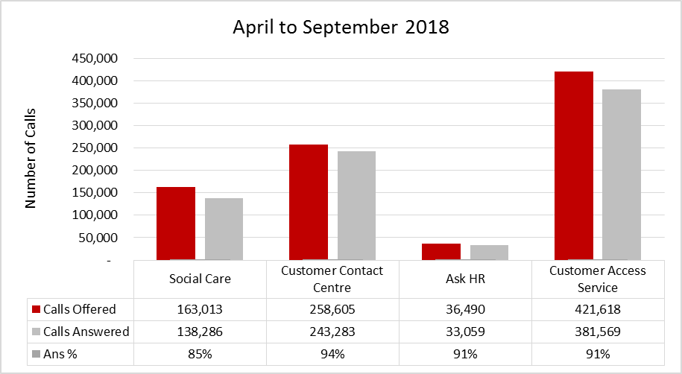

Telephony performance – April to June 2018

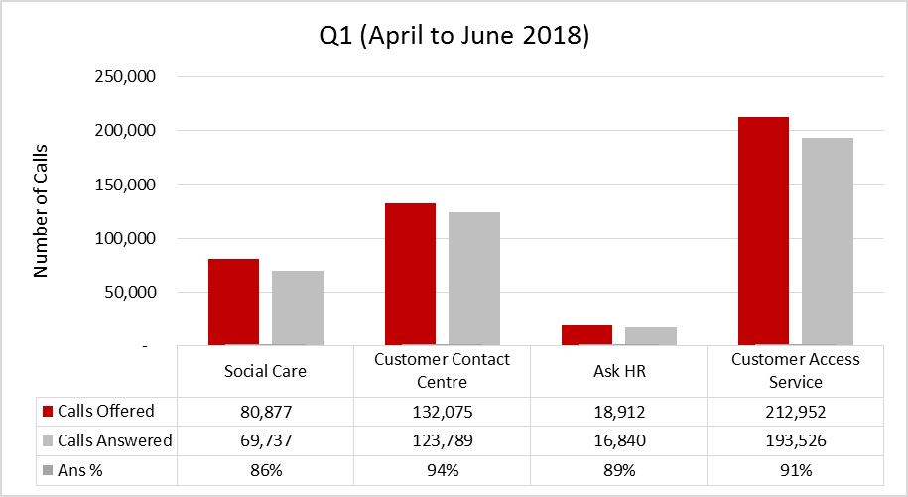

Telephony performance – July to September 2018

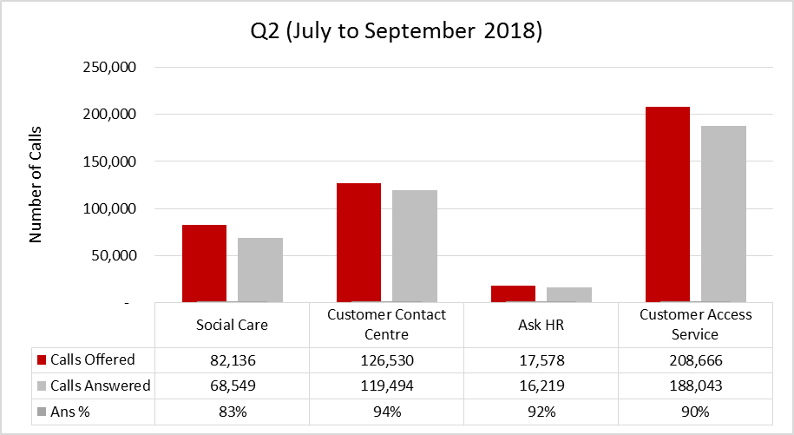

Email performance – April to September 2018

Email performance – April to June 2018

Email performance – July to September 2018

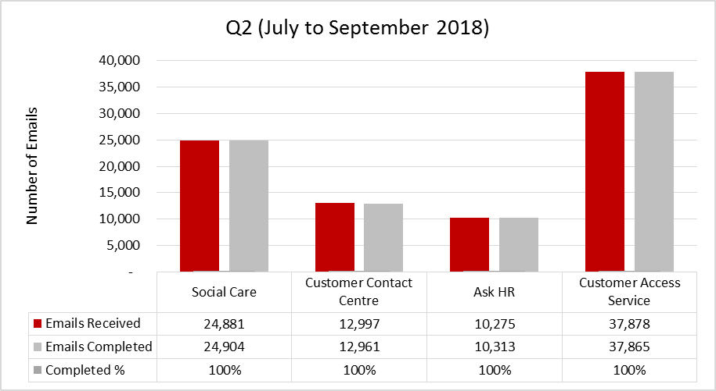

Compliments and Complaints

The number of overall compliments the Customer Access Service has received so far during 2018/2019 is 34 with the number of complaints received being 24. Both figures are from a total number of 553,562 contacts received.

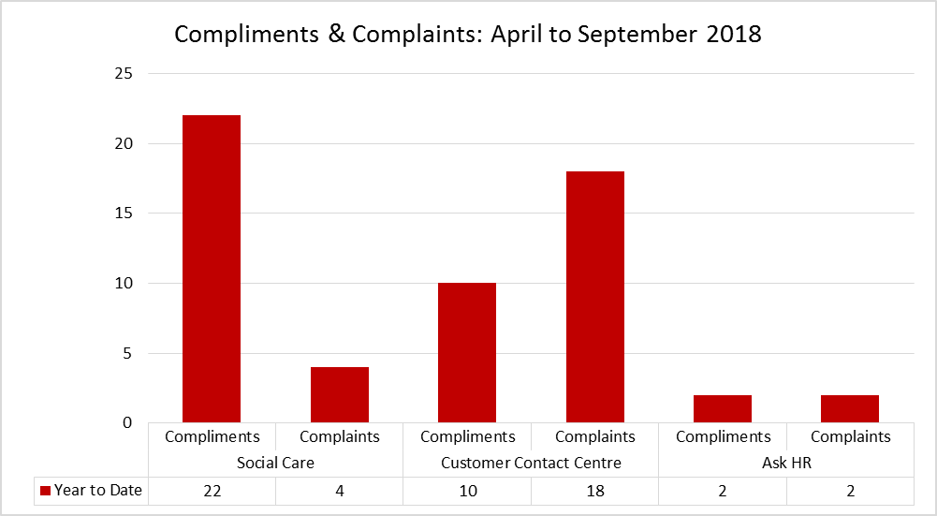

Future Improvements
Genesys Programme Phase 2 - Technology Improvements
As part of the Genesys Phase 2 project, the Customer Access Service will benefit from the delivery of several important work streams:

- Auto Attendant Utterance – an intelligent piece of software that recognises speech to effectively routes calls to the customer's desired service. This will be implemented on the signposting line.
- Auto Attendant Call By Name – software that will effectively route calls to a person rather than a service for an improved customer experience. This will be implemented on the Social Care line and route calls to social workers and other members of staff.
- Data integration – an application that will pre-populate a customer's information into a system once connected to an advisor, generating an improvement to customer experience and a reduction of handling time.
- Skype and Email Integration – for ease of use and an improved customer experience, advisors will have the ability to transfer calls and emails immediately by entering the name of the desired contact within Genesys rather than search for it in another system.
- Social Media & Webchat – implementation of alternative contact channels for customers to contact the Customer Access Service.
- Acorn POP – an application to pre-populate processes and guidance to advisors based on the customer's query, improving efficiency and consistency of service.

All of the work streams to be delivered are intended to ensure an improved way of working for the benefit of the customer. Customer Access are working side by side with BT Lancashire Services and Anana (the software provider) to ensure that the deliverables are utilised to their full potential.

Blue Badge Improvements
Due to the current Department for Transport contract coming to an end, we are in the process of bringing in a new Client Management System. This will be provided by Northgate and will be an enhancement on their current product which is included as part of the Department for Transport contract. The new system will allow greater reporting and forecasting ability to support better planning within the service, as well as offering enhanced usability and functionality.

We have also made several improvements to our Blue Badge processes in order to make them more efficient and accurate. These include working closely with Able2 Occupational Therapy, who provide Independent Medical Assessments on unclear cases, and changing the requirements for a new applicant's photograph. In addition to this, the Department for Transport will bring in some new guidance in 2019 to bring parity to those with non-physical or hidden disabilities. This work has been added to our Blue Badge improvement plan to ensure that we are prepared for these changes and also to help manage the transitional period.

Winter Refresher
As part of our commitment to the Highways service, Customer Access delivered winter refresher briefings in October to all trained advisors, covering key areas such as gritting and flooding. This content is developed based on input from Communications, Highways and Customer Access lessons learned from the previous year.

Emergency Planning
Our business continuity facility at Marsh Lane, Preston was fully tested in both June and October this year. The facility was also used several times during May, June and July in order to support staff during train strikes.

Customer Access Service attended Day 2 of Exercise Falcon Rose in April 2018 and provided a tactical representative for Nuclear Exercise in October.

Our Service Resilience Plan is being reviewed for submission to Health, Safety and Resilience at the end November 2018 and our business continuity arrangements are currently being audited by the internal Lancashire County Council Audit Team.

Health and Safety
The Health, Safety and Resilience service conducted a Health and Safety survey with all Customer Access Service staff, the results of which were delivered in January 2018.

Improvements made as a result of the survey include:
- A review of First Aider resource and the re-establishment of First Aider meetings,
- A new training package for Display Screen Equipment Assessors to ensure actions identified in risk assessments are implemented,
- The use of the Customer Access Service intranet for key health and safety information, and
- The establishment of a building user group with Facilities Management.
Staff Surveys and briefings
In early 2018, the Customer Access Service completed a number of staff briefing sessions to communicate the results of the Customer Access Service staff survey which was completed by 162 members of staff in 2017. The briefings allowed staff to contribute to the areas requiring improvement and a variety of suggested ideas have now been implemented.

A further Customer Access Service staff survey will be completed in 2018 to build on the corporate staff survey and ensure that we continually engage with, and listen to, our staff.

Service Challenge
The Customer Access Service Challenge was scheduled for September 2018 and involved a substantial amount of work, conducting research, investigating proposals and developing options to share across the organisation with our senior and corporate management teams, and our elected members.

Consultations

Internal/external customers and service areas, including the Customer Access Service and HR staff.

Implications:

This item has the following implications, as indicated:

Risk management

This report is for noting and therefore a risk analysis in relation to the content on this report has not been required.

Financial Implications

There are no financial implications arising from this report.

Local Government (Access to Information) Act 1985

List of Background Papers

Paper | Date | Contact/Directorate/Tel
None
Reason for inclusion in Part II, if appropriate

N/A

